**HO CHI MINH CITY NATIONAL UNIVERSITY**

**UNIVERSITY OF NATURAL SCIENCES**  
FACULTY OF INFORMATION TECHNOLOGY

**Test Summary Report**

Subject: Software Testing

**Instructor Guides:**

MSc. Trần Thị Bích Hạnh  
BSc. Hồ Tuấn Thanh  
BSc. Trương Phước Lộc

Ho Chi Minh City, July 21st, 2024

CONTENTS

A. INTRODUCTION 3

1. Group information 3

2. Assigned task 3

B. PURPOSE 4

1. Purpose 4

2. Application Overview 4

3. Testing Scope 4

3.1. In Scope 4

3.2. Items not tested 4

4. Metrics 4

4.1. No. of test cases planned vs executed (passed/failed) 4

*4.1.1.* *Build 1* 4

*4.1.2.* *Build 2* 5

4.2. No of defects identified and their Status & Severity 5

4.3. Defects distribution – module wise 6

5. Types of testing performed 7

4.5. Smoke Testing 7

4.6. System Integration Testing 7

4.7. Regression Testing 7

6. Test Environment & Tools 7

7. Lessons Learnt 7

8. Exit Criteria 8

9. Conclusion/Sign Off 8

1. INTRODUCTION
2. Group information

|  |  |  |  |
| --- | --- | --- | --- |
| **GROUP 14** | | | |
| **No.** | **Student ID** | **Full name** | **Email** |
| **1** | 21127234 | Nguyễn Lê Anh Chi | [nlachi21@clc.fitus.edu.vn](mailto:nlachi21@clc.fitus.edu.vn) |
| **2** | 21127235 | Nguyễn Xuân Quỳnh Chi | [nxqchi21@clc.fitus.edu.vn](mailto:nxqchi21@clc.fitus.edu.vn) |
| **3** | 21127495 | Lê Ngô Song Cát | [lnscat21@clc.fitus.edu.vn](mailto:lnscat21@clc.fitus.edu.vn) |
| **4** | 21127659 | Bùi Ngọc Kiều Nhi | [bnknhi21@clc.fitus.edu.vn](mailto:bnknhi21@clc.fitus.edu.vn) |

1. Assigned task

| **No.** | **Responsibility** | **Task** | **Level of completion** |
| --- | --- | --- | --- |
| **1** | Nguyễn Lê Anh Chi | Design, execute, report TCs for module Register, CRUD-TestPlan, Search, CRUD-Administration. | 100% |
| **2** | Nguyễn Xuân Quỳnh Chi | CRUD-Issues, CRUD-Test Cases, CRUD-Releases | 100% |
| **3** | Lê Ngô Song Cát | Design, execute, report TCs for module Test Runs, Update User, Projects | 100% |
| **4** | Bùi Ngọc Kiều Nhi | Design, execute, report TCs for a part of CRUD requirement, CRUD module, CRUD report | 100% |

1. PURPOSE
   1. Purpose

This document explains the various activities performed as part of Testing of a web application which is a bug tracking system called ShareBug.

* 1. Application Overview

ShareBug is a bug tracking system where they allow users to report test case, make test plans and anything related to testing, act as a tool to keep track of software defects.

* 1. Testing Scope



## In Scope

|  |  |  |  |  |  |
| --- | --- | --- | --- | --- | --- |
| **Test type** | **Functional** | **Security** | **GUI&Usability** | **Perfomance** | **Compatibility** |
| **CRUD-TestPlan** | x |  | x |  |  |
| **CRUD-Administration** | x |  | x |  |  |
| **Register** | x |  | x |  |  |
| **Search** | x |  | x |  |  |
| **CRUD-Issues** | x |  | x |  | x |
| **CRUD-Test Cases** | x |  | x |  | x |
| **CRUD-Releases** | x |  | x |  | x |

## **Items not tested**

* None.
  1. Metrics



## No. of test cases planned vs executed (passed/failed)



## *Final release*

|  |  |  |  |  |  |
| --- | --- | --- | --- | --- | --- |
| **Test cases** | | | | | |
| **Planned** | **Executed** | **Passed** | **Failed** | **Blocked** | **Skipped** |
| 48 | 48 | 23 | 21 | 3 | 1 |

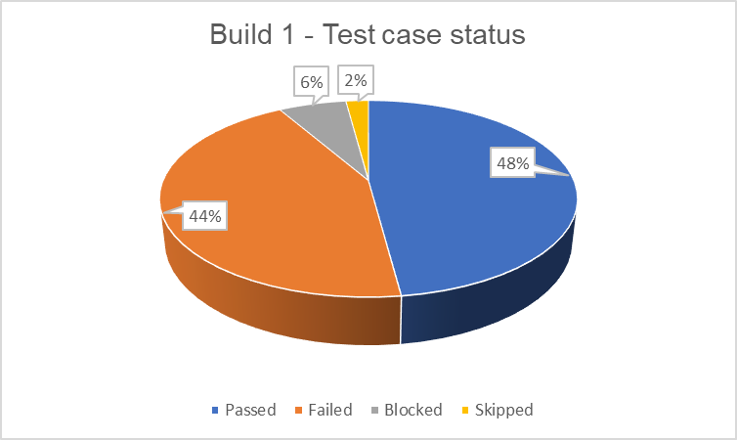

## *Build 2*

|  |  |  |  |  |  |
| --- | --- | --- | --- | --- | --- |
| **Test cases** | | | | | |
| **Planned** | **Executed** | **Passed** | **Failed** | **Blocked** | **Skipped** |
| 58 | 58 | 37 | 19 | 1 | 1 |

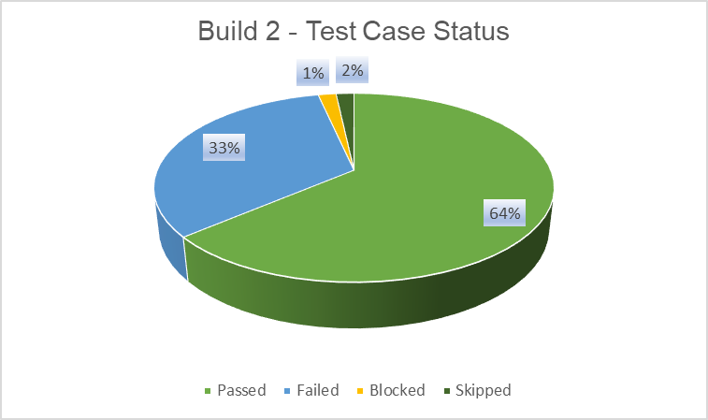

## No of defects identified and their Status & Severity

|  |  |  |  |  |  |
| --- | --- | --- | --- | --- | --- |
|  | **Major** | **Minor** | **Tweak** | **Trivial** | **Total** |
| **Closed** | 2 | 7 | 1 | 2 | 12 |
| **Open** | 6 | 13 | 0 | 1 | 19 |
|  |  | | | | 32 |

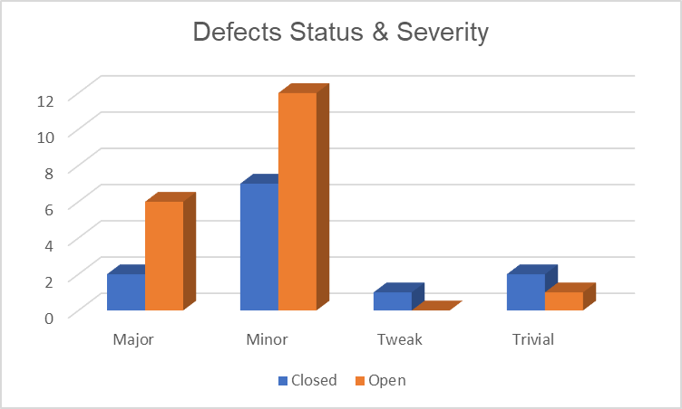

## Defects distribution – module wise

|  |  |  |  |  |  |  |  |  |
| --- | --- | --- | --- | --- | --- | --- | --- | --- |
|  | **CRUD-Administration** | **Register** | **Login** | **Details** | **Comments - Pagination** | **Add Comment** | **Delete Comment** | **Total** |
| **Major** | 1 | 2 | 5 | 0 | 1 | 0 | 0 | **9** |
| **Minor** | 4 | 0 | 1 | 4 | 3 | 4 | 3 | **19** |
| **Tweak** | 0 | 0 | 0 | 0 | 0 | 1 | 0 | **1** |
| **Trivial** | 0 | 0 | 0 | 0 | 1 | 2 | 0 | **3** |
| **Total** | **5** | **2** | **6** | **4** | **5** | **7** | **3** | **32** |

* 1. Types of testing performed

## Smoke Testing

* Conducted whenever a new build is received and deployed into the test environment. This ensures that the primary functionalities are working correctly, allowing the build to be accepted and testing to commence.

## System Integration Testing

* + Performed on the application to verify it operates according to the requirements.
  + Critical business scenarios are tested to ensure essential functionalities function correctly without errors.

## Regression Testing

* Executed each time a new build is deployed for testing, which includes defect fixes and any new enhancements.
* Regression testing covers the entire application, not just the new features and defect fixes, ensuring that existing functionalities remain unaffected by recent changes. New test cases are added for new functionalities and executed alongside the existing ones.
  1. Test Environment & Tools

|  |  |
| --- | --- |
| **Application URL** | <http://localhost:4000> (the website link is down) |
| **Apps Server** | 192.168.xxx.22 |
| **Database** | MongoDB |
| **HP QC/ALM** | 192.168.xxx.22 |

* 1. Lessons Learnt

|  |  |  |
| --- | --- | --- |
| **S. No** | **Issues faced** | **Solutions** |
| 1 | Smoke testing test cases required to be executed manually each time, leading to time consumption and potential human error. | Smoke test cases were automated, and the scripts were run, which ran fast and saved time, reducing the effort needed for manual testing and minimizing human error. |
| 2 | Initially, a few testers did not have rights to change defect status in HP QC/ALM. Test lead is needed to perform this task. | Rights were obtained from Client, by explaining the difficulty. |

* 1. Exit Criteria

1. All test cases should be executed.
2. All defects in Critical, Major severity should be verified and closed.
3. Only 2 defects in Medium severity should be ‘OPEN’.
   1. Conclusion/Sign Off

As the Exit criteria was met and satisfied as mentioned in Section 8, this application is not suggested to ‘Go Live’ by the Testing team. Appropriate User/Business acceptance testing should be performed before ‘Go Live’.